**Senga SDE System Architecture: Consolidation-Optimized Sequential Decision Engine**

**System Context Diagram**

**External Actors and Systems**

**1. Shippers (e.g., Tropical Heat)**

* **Interactions IN:**
  + Submit orders via API (shipper → multiple retail destinations)
  + Provide shipment specifications (weight, volume, fragility, time windows)
  + Specify delivery priorities and SLA requirements
  + Receive consolidation assignments and pickup schedules
* **Interactions OUT:**
  + Get pickup time windows
  + Receive shipment tracking updates (manual waypoint-based)
  + Get delivery confirmation with proof of delivery
  + Access billing and invoice data

**2. Retail Customers (e.g., Naivas, Chandarana, Carrefour)**

* **Interactions IN:**
  + Receive consolidated deliveries (multiple shippers in one truck)
  + Provide receiving time windows and dock availability
  + Confirm deliveries and report issues
* **Interactions OUT:**
  + Pre-delivery notifications (consolidated manifest)
  + Delivery ETA updates
  + Post-delivery feedback

**3. Drivers (Hired/Contracted Trucks)**

* **Interactions IN:**
  + Receive consolidated route manifests with:
    - Pickup sequence from multiple shippers
    - Delivery sequence to multiple retailers
    - Load consolidation instructions (which items go where)
    - Optimized routing considering mesh network
  + Manual GPS updates at waypoints
* **Interactions OUT:**
  + Report pickup completions (per shipper)
  + Report delivery completions (per retail customer)
  + Update truck capacity status
  + Flag issues (delays, capacity overruns, access problems)

**4. Fleet Manager**

* **Interactions IN:**
  + Monitor truck utilization (target: >75%)
  + View consolidation efficiency metrics
  + Receive capacity planning recommendations
* **Interactions OUT:**
  + Update truck availability and specs
  + Approve/modify strategic fleet allocation
  + Set operational constraints

**5. Operations Team**

* **Interactions IN:**
  + Monitor real-time consolidation decisions
  + Review exception alerts (low utilization, missed consolidations)
  + Access consolidation analytics and what-if scenarios
* **Interactions OUT:**
  + Override consolidation decisions when necessary
  + Adjust consolidation parameters (min utilization thresholds)
  + Validate learning system recommendations

**External Systems**

**6. Order Management System (Senga OMS)**

* **Interactions:**
  + **IN:** Real-time order stream via API
  + **IN:** Order updates, cancellations, modifications
  + **OUT:** Consolidation assignments back to OMS
  + **OUT:** Optimized pickup/delivery schedules
  + **Format:** REST API with webhook callbacks

**7. Shipper APIs (Multiple)**

* **Interactions:**
  + **IN:** Order submissions, shipment details
  + **OUT:** Pickup scheduling, consolidation notifications
  + **OUT:** Tracking updates (waypoint-based)

**8. Google Places API**

* **Interactions:**
  + **IN:** Address validation and geocoding
  + **IN:** Route distance/duration estimates
  + **OUT:** Validated addresses with GPS coordinates
  + **Constraint:** Rate limits, API costs

**9. Notification Service**

* **Interactions:**
  + **OUT:** SMS/Email to shippers and retailers
  + **OUT:** Driver app notifications

**Senga SDE System Boundary**

**Core Problem Statement**

**Sequential Decision Problem:** Given a stream of small orders from multiple shippers to multiple retail destinations, dynamically decide:

1. **Which orders to consolidate** into each truck run
2. **When to dispatch** (vs. waiting for more consolidation opportunities)
3. **Which route to take** through the mesh network
4. **How to sequence pickups and deliveries** to maximize efficiency

Subject to:

* **Profitability constraint:** Capacity utilization ≥75%
* **Time constraint:** All deliveries within 2 days of order receipt
* **No warehousing:** Direct mesh routing only
* **Capacity constraint:** Truck weight/volume limits
* **Time window constraints:** Shipper pickup hours, retailer receiving hours

System Architecture: Three-Layer Sequential Decision Framework

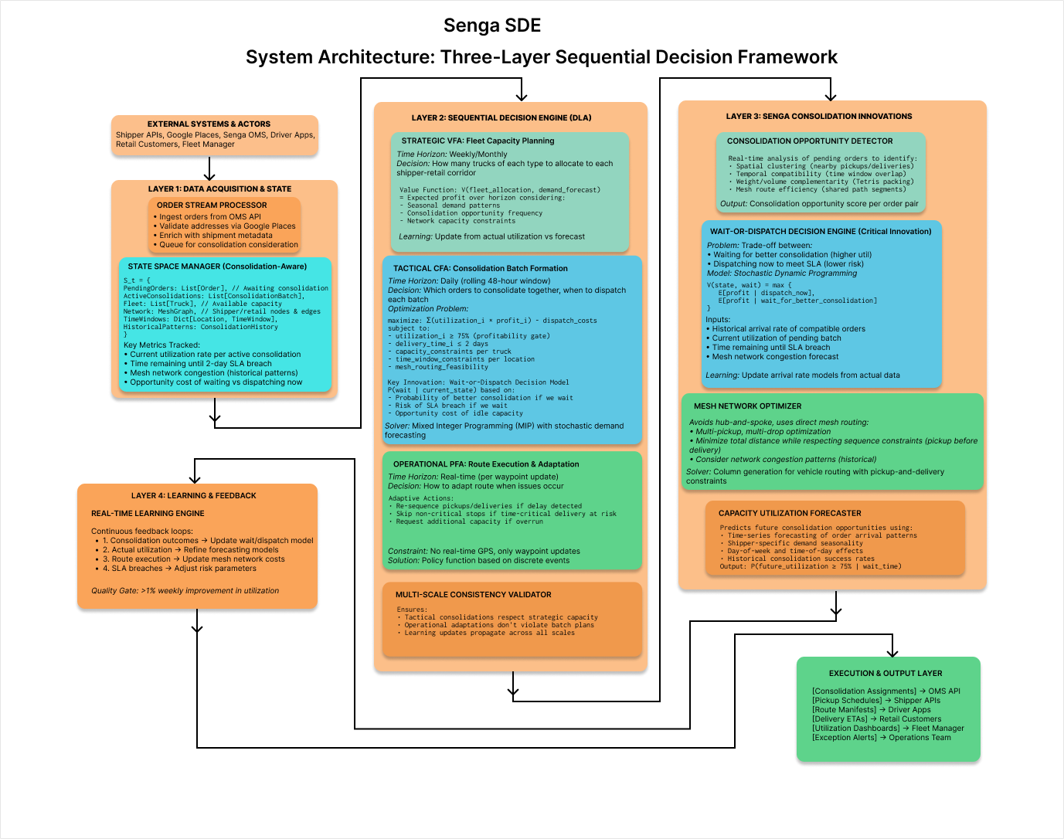

**Key Architectural Decisions**

1. State Space Design (Consolidation-Centric)

@dataclass

class ConsolidationState:

    # Pending orders awaiting consolidation

    pending_orders: List[Order]  # Each with origin, destination, weight, volume, time_window

    # Active consolidation batches (not yet dispatched)

    active_batches: List[ConsolidationBatch]  # Each tracking current utilization

    # Fleet availability

    available_trucks: List[Truck]  # With capacity specs

    en_route_trucks: List[Truck]  # With current waypoint

    # Network state

    mesh_graph: NetworkGraph  # Shipper/retail nodes, historical edge costs

    # Time constraints

    current_time: datetime

    sla_deadlines: Dict[OrderID, datetime]  # 2-day deadline per order

    # Learning state

    historical_patterns: ConsolidationHistory  # Past success rates, arrival patterns

    utilization_forecast: UtilizationModel  # Predicted future opportunities

2. Action Space Design

@dataclass

class ConsolidationAction:

    # Primary decision

    decision_type: Literal["WAIT", "DISPATCH", "REJECT"]

    # If DISPATCH:

    batch_assignment: Dict[OrderID, TruckID]

    pickup_sequence: List[ShipperID]

    delivery_sequence: List[RetailID]

    mesh_route: List[Waypoint]

    # If WAIT:

    wait_duration: timedelta

    target_utilization: float  # Desired util before dispatch

    # Metadata

    expected_utilization: float

    expected_profit: float

    risk_of_sla_breach: float

3. Sequential Decision Flow (Critical Path)

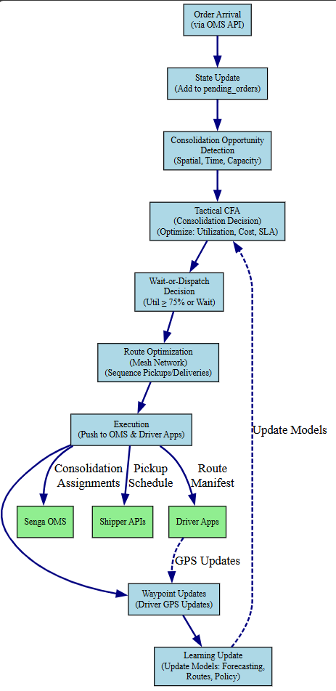

Senga SDE Component Interaction Diagram & Mathematical Formulation

Part 1: Component Interaction Diagram (Detailed Message Flows)

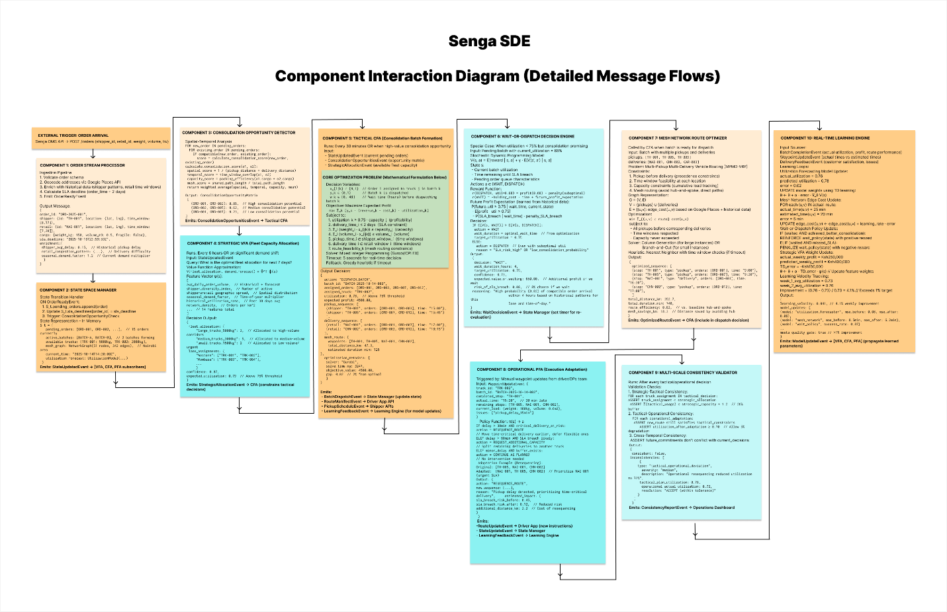

**Part 2: Mathematical Formulation of Core Consolidation Problem**

**Problem Statement**

Given a set of orders arriving over time, decide which orders to consolidate into truck runs such that profit is maximized while respecting capacity, time window, and utilization constraints.

**Sets and Indices**

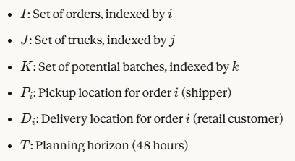

**Parameters**

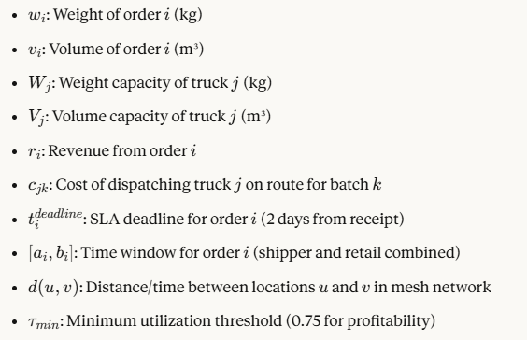

Decision Variables

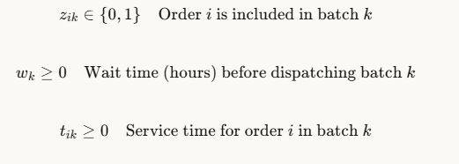

**Objective Function**

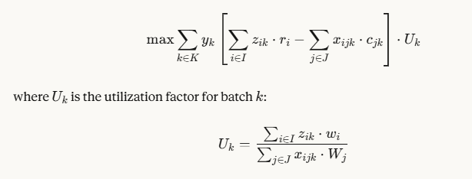

**Interpretation:** Maximize total profit across all batches, weighted by utilization (incentivizes high-utilization batches).

**Constraints**

**1. Profitability Constraint (Critical for Senga)**

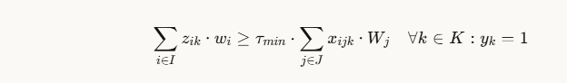

**Meaning:** If batch *k* is dispatched, weight utilization must be ≥75%.

Volume variant:



**2. Capacity Constraints**

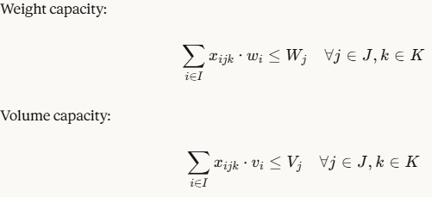

**3. Order Assignment Constraints**

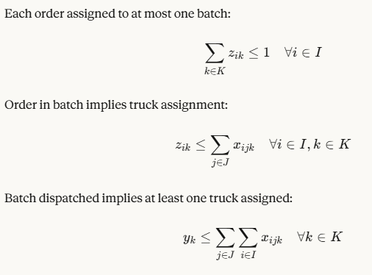

**4. SLA (Two-Day Delivery) Constraints**



**Meaning:** Order service time plus wait time cannot exceed 2-day deadline.

**5. Time Window Constraints**

Pickup time window:



Delivery time window:



Precedence (pickup before delivery):



where *τPi*​​ is the service time at pickup location.

**6. Mesh Routing Constraints**

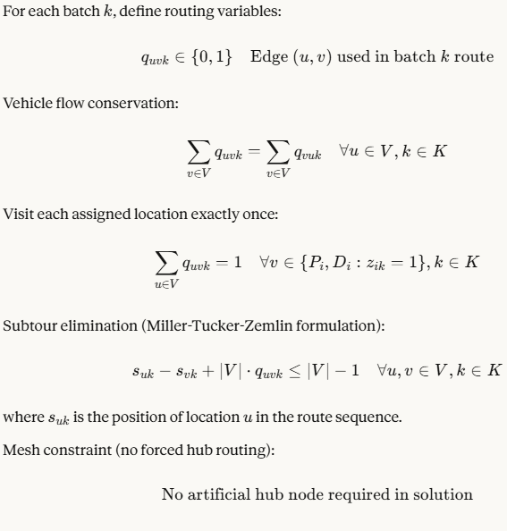

**7. Wait-or-Dispatch Decision Constraints**

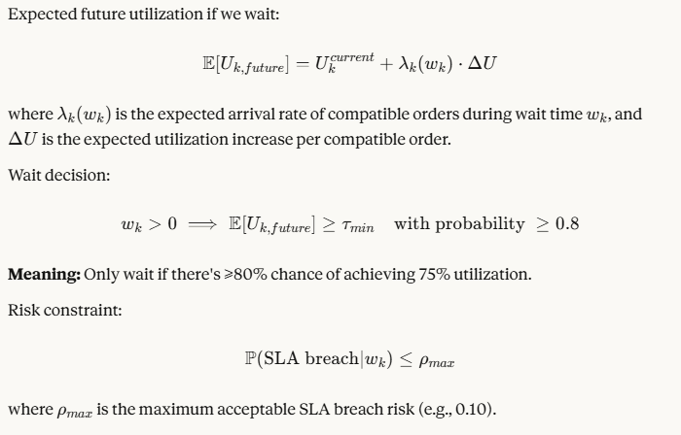

**Stochastic Elements (Wait-or-Dispatch Model)**

**Markov Decision Process F**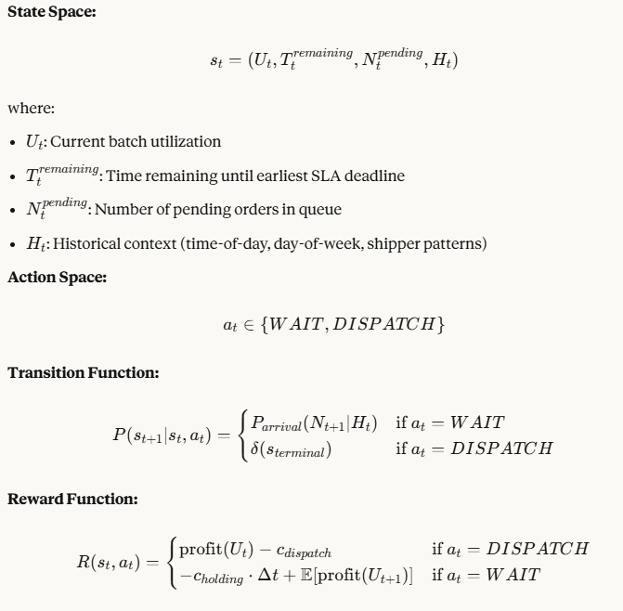

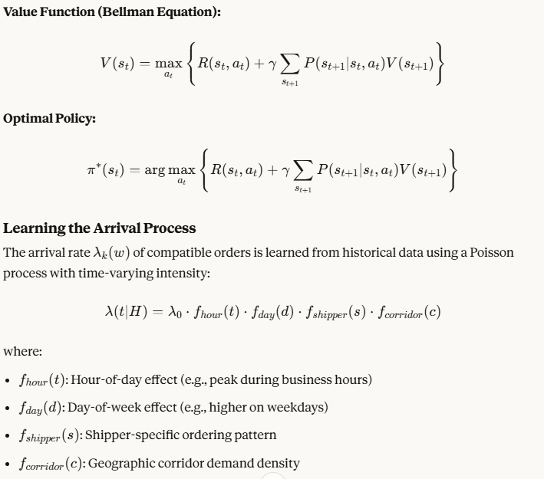

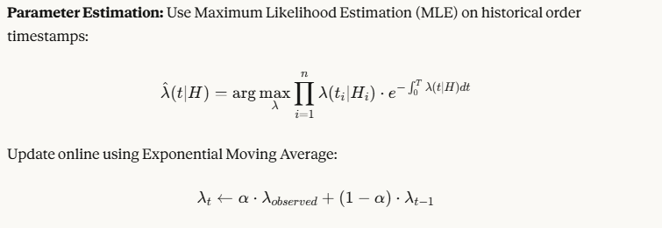

**Solution Approach**

**Two-Stage Stochastic Programming**

**Stage 1 (Tactical CFA):** Decide on batch composition and dispatch timing **Stage 2 (Operational PFA):** Adapt to realized demand and execution issues

**Formulation:**



subject to Stage 1 constraints (above), where *ξ* represents random variables (future order arrivals, travel times, delays).

**Sample Average Approximation (SAA):**

Generate *N* scenarios of future demand:



Solve deterministic equivalent:

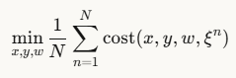

**Decomposition for Scalability**

**Benders Decomposition:**

Master Problem (batch assignment):

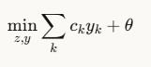

subject to:

* Order assignment constraints
* *θ≥Q(z,y) (*subproblem optimal value)

Subproblem (routing for fixed batch):

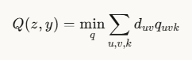

subject to:

* Mesh routing constraints for batch *k*
* Time window constraints

Iterate until convergence.

ALGORITHM: ConsolidationBatchOptimizer

INPUT:

  - pending_orders: Set of unfulfilled orders

  - available_trucks: Set of trucks with capacity specs

  - current_time: Timestamp

  - historical_data: Past consolidation patterns

OUTPUT:

  - batch_decisions: List of (orders, truck, route, dispatch_time)

PROCEDURE:

1. OPPORTUNITY_DETECTION:

   FOR each pair (o_i, o_j) in pending_orders:

     score[o_i, o_j] = consolidation_score(o_i, o_j)

   clusters = spatial_temporal_clustering(pending_orders, score)

2. FOR each cluster in clusters:

   2.1 BATCH_FORMATION:

       Initialize batch_k with cluster orders

       current_util = calculate_utilization(batch_k)

   2.2 WAIT_OR_DISPATCH_DECISION:

       IF current_util >= 0.75:

         decision = DISPATCH

       ELSE:

         // Stochastic optimization

         V_wait = expected_value_of_waiting(batch_k, historical_data)

         V_dispatch = profit(current_util) - dispatch_cost

         IF V_wait > V_dispatch AND sla_risk_acceptable:

           decision = WAIT

           wait_time = optimal_wait_duration(batch_k)

           schedule_reevaluation(batch_k, current_time + wait_time)

         ELSE:

           decision = DISPATCH

   2.3 IF decision == DISPATCH:

       2.3.1 TRUCK_ASSIGNMENT:

             truck = assign_optimal_truck(batch_k, available_trucks)

       2.3.2 ROUTE_OPTIMIZATION:

             pickups = [order.pickup_location for order in batch_k]

             deliveries = [order.delivery_location for order in batch_k]

             route = solve_MPMD_VRP(

               pickups, deliveries, truck.capacity,

               mesh_network_graph, time_windows

             )

       2.3.3 VALIDATION:

             IF NOT validate_sla_compliance(route, batch_k):

               REJECT batch_k

               Continue

             IF NOT validate_time_windows(route):

               route = adaptive_resequencing(route)

             utilization_final = calculate_utilization(batch_k)

             IF utilization_final < 0.75:

               LOG warning: "Suboptimal batch dispatched"

       2.3.4 OUTPUT:

             batch_decisions.append({

               orders: batch_k,

               truck: truck,

               route: route,

               dispatch_time: current_time,

               utilization: utilization_final

             })

3. CONSISTENCY_CHECK:

   FOR each batch_decision in batch_decisions:

     validate_multi_scale_consistency(batch_decision)

4. LEARNING_UPDATE:

   FOR each batch_decision in batch_decisions:

     queue_for_learning_feedback(batch_decision)

RETURN batch_decisions

END PROCEDURE

```

---

## Complexity Analysis

### Computational Complexity

**Consolidation Opportunity Detection:** $O(|I|^2)$

- Pairwise comparison of all pending orders

**Batch Formation (MIP):** $O(2^{|I|} \cdot |J| \cdot |K|)$ (worst case)

- NP-hard in general, but practically solvable for small instances with modern solvers

- Typical instance: 50 orders, 10 trucks, 20 batches → solvable in seconds

**Mesh Route Optimization (MPMD-VRP):** $O(|V|!)$ (worst case)

- NP-hard, but branch-and-cut or heuristics yield good solutions quickly

- Typical instance: 6 pickups, 8 deliveries → solvable in milliseconds

**Wait-or-Dispatch MDP:** $O(|S| \cdot |A| \cdot T)$ per evaluation

- Discrete state space makes this tractable

- Value iteration converges in $O(T \cdot |S|^2)$

**Total Decision Time Budget:** 5 seconds for real-time operation

- If MIP timeout, fall back to greedy heuristic

- Heuristic guarantees feasible solution in $O(|I| \cdot \log |I|)$

